1. 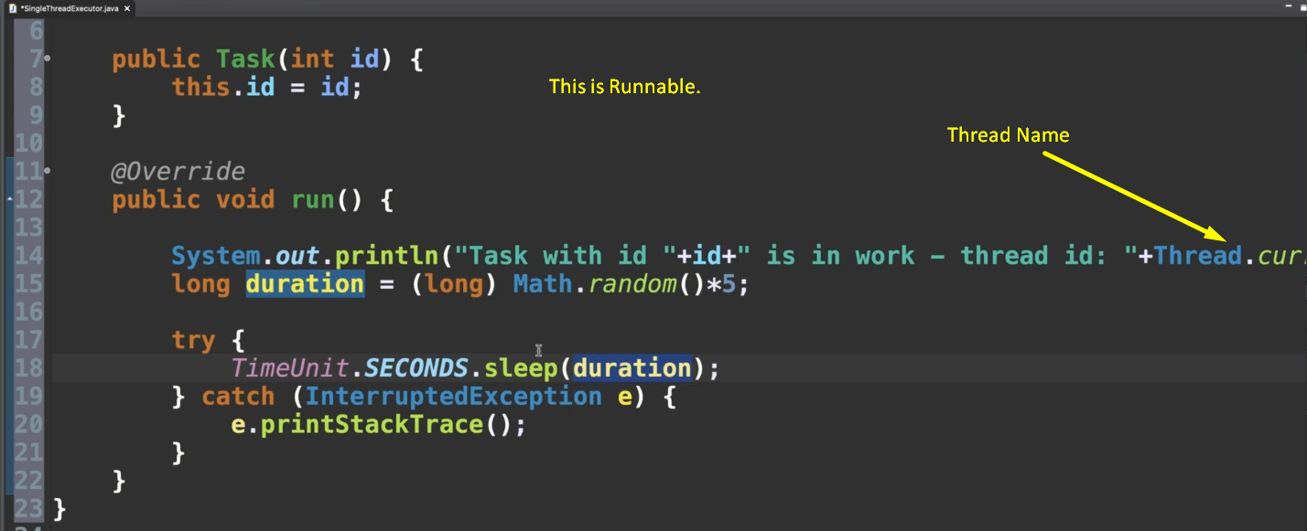
2. 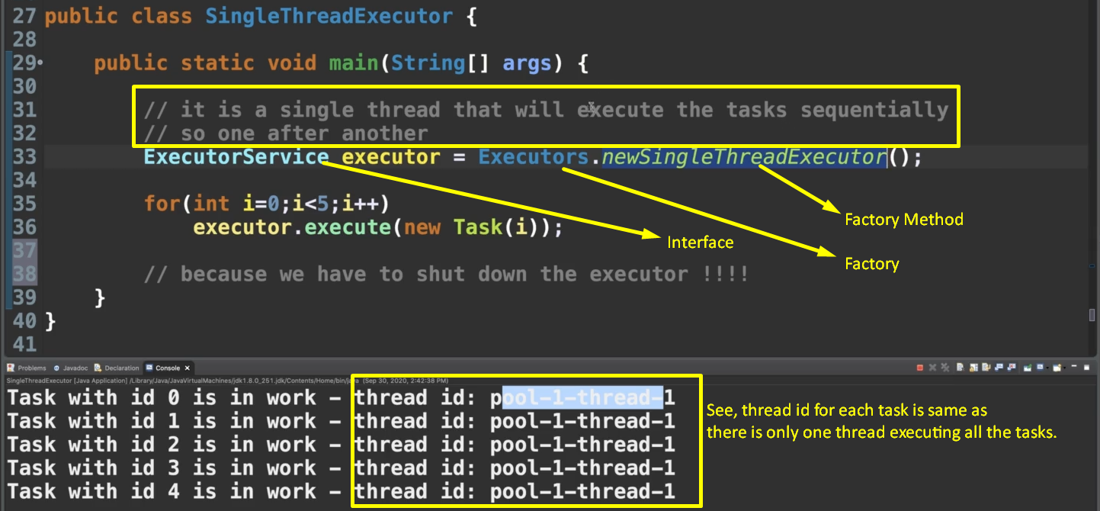
3. Above note that when all the tasks are fully executed, the application doesn’t terminate.   
   This is because the single thread is still alive and we know that when all non-daemons threads are dead only then program terminates.